Cheyenne Hathaway

Manuel Zacarias

Quentin Smith

Khoi Xa

**AI Applied in Agriculture**

What is now known as the fourth industrial revolution, a term coined for the implementation of computing technologies to automate and streamline tasks in all sectors of society, is having a significant impact on humanity. As is the case with AI, which is being integrated into numerous aspects of our daily lives every day. The accelerated development of AI technologies has provided the possibility of finding more effective solutions to problems in daily life, therefore obtaining greater optimization of results. In this report we will discuss the implementation of AI in agriculture. We will offer context to the topic by providing information about the technologies and techniques implemented, the benefits and challenges of these technologies, the impact and ethical considerations in society, and the future trends that this emerging technology brings to the agricultural sector.

The implementation of AI in agriculture is revolutionizing agriculture by providing tools that help farmers meet future global food needs. The application of these AI-powered tools is bringing positive change by improving productivity, sustainability, and cost savings in this sector. These new trends are helping farmers make better decisions regarding crop management, resource optimization, and pest control. According to Ranveer Chandra, general manager of industry research and chief technology officer for Agri-Food at Microsoft, “Digital agriculture promises to help address many of the global challenges facing agriculture.” This is thanks to various techniques and technologies used in the field of AI which we will now introduce:

1. Machine Learning (ML): This is the most widely used technique in this sector. By using machine learning algorithms and AI models, it is possible to analyze data within the agricultural sector to be applied to different purposes. This includes climate monitoring systems, automated irrigation and fertilizer systems, trends or products in demand within the market, and more.
2. Computer vision: Computer vision techniques can be used to implement devices that detect pests, analyze crop growth, or take samples for analysis
3. Robots and autonomous machinery: These two technologies are equipped with AI technologies and sensors to perform certain tasks. Robots are used to monitor the ripeness of crops and harvest them. The use of autonomous machinery works to prepare the land, sow seeds, or irrigate water.
4. Drones: The use of drones incorporated with computer vision and LIDAR systems in agriculture provides more efficient monitoring in relation to pest detection, monitoring the status of crops, and supervising large areas of crops that can take more time for humans.
5. Internet of Things technology: This technology, together with smart applications and sensors, can share in real-time data on the status of crops, soil moisture levels, weather alerts, and more.
6. Smart sensors and automatic devices: The combination of these two technologies is effective in optimizing resources and saving costs. Devices with sensors can detect if a crop is infested with pests, while automatic devices can be programmed to detect at what times of the day it is appropriate to irrigate.

Through the implementation of AI in agriculture, farmers are able to collect and process large amounts of data to keep up with the increasing demands of the growing global population. Because they are able to collect and process data in real time within virtually every step of production, they are able to address problems immediately. Not only does this aid in keeping up with global demands, but it also allows for increased financial gain for these farmers.

The sensors mentioned above collect data 24 hours a day, checking everything from crop fertility, soil condition, and temperature. This adds a level of efficiency and cost saving benefits as prior to the introduction of AI, this was a labor and time intensive project. This erases the possibility of issues going unnoticed, allowing them to be immediately addressed. Farmers are able to monitor several fields, with several different crops. In addition, because these sensors can also monitor the soil, they can be combined with machine learning models, signaling to farmers when crops need to be rotated to prevent issues like nutrient leaching. These models can also be set to guide planting seasons for optimal crop yield, as well as monitor possible disease risks or outbreaks.

AI is also used to analyze for early detection of disease, as well as diagnosis of the disease, aiding in farmers ability to effectively address it, allowing them to preserve more of their crops. This is allowed through the use of computer vision and data analysis. By combining these, AI models are able to use not just the image, but also things such as geographic location and season, to diagnose with increased accuracy.

Several other aspects of farming outside of crop health and soil condition see benefits stemming from the use of AI. It is used to monitor weather, and temperature to guide farmers on the best time to plant and harvest. These do not require physical sensors, as it can be run using historic data. This provides a cost effective way of increasing crop yield even for smaller farms that do not currently have the financial ability to utilize the costlier technologies mentioned above.

However, there are challenges facing farmers when implementing these technologies, the most obvious of which being cost. Farmers with a smaller production area or in more rural or underdeveloped areas face issues with affording these emerging technologies. Many of these sensors, drones, robots, and more require a significant upfront cost that deter or entirely prevent some farmers from implementing it in their business. While trends show that these things increase production and therefore revenue long term, the upfront cost is an undeniable barrier. Additionally, while some AI solutions are more affordable (some crop disease detection models can be used with just a smartphone), farmers in underdeveloped areas can face issues even just in accessing the internet. This can then translate to these smaller farms being pushed out of business as they struggle to keep up with the production of larger farms that have easier access to technology. In addition, even with access to technology, some farmers lack the experience necessary to effectively utilize it, or are simply resistant to the idea of bringing technology to their farms. Lastly, there are some concerns around the environmental impacts of increased use of technology. Producing and running these technologies can lead to higher rates of energy consumption, which means farmers need to be particularly aware of the environmental impact of their use.

**Ethical and Societal Implications:**

Adopting AI into agriculture is a very broad term of approach. It could be a small implement such as real time weather monitoring, so that farmers can be notified immediately of any concerning weather events. In contrast, it could be a significant change, such as a (future) scenario in which everything is replaced by robots that have synchronized their artificial brain with the cloud so that everything farmed will be controlled at the utmost certainty.

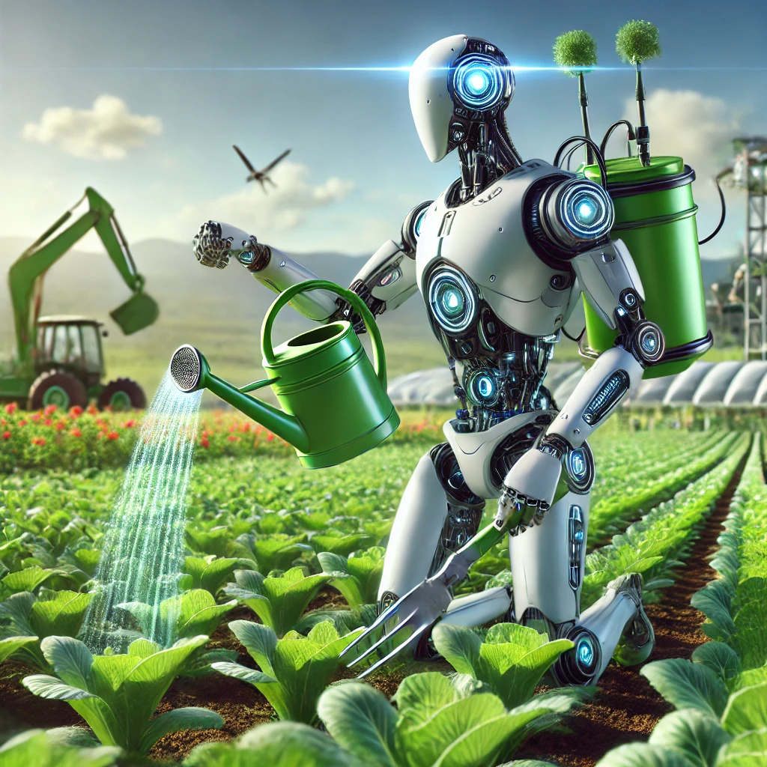

Source: ChatGPT

That scenario will mean the end of human farming. Farmers will be replaced by farming robots, which lead the question back to the age old ethical question:

*Is it ethical to replace humans with machines ?*

New technology inherently brings about change that affects people's lives in a controversial way. In the 1890s, the Industrial Revolution made people flock to the cities. With an increased population, there was an increase in the number of horses, and with them, more manure.

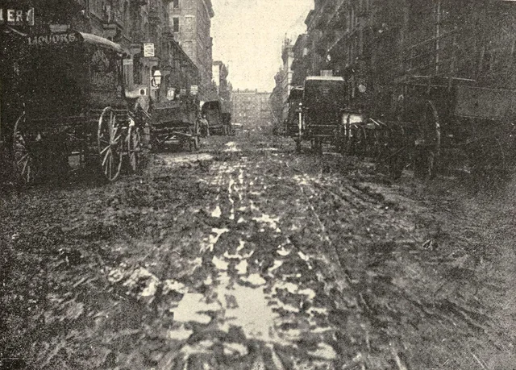

*Morton street in New York full of manure, 1893*

It was predicted that by the 1950s, there would be 9ft of manure covering the street. But a new technology would destroy those concerns: the car. Concerns over the manure rapidly decreased as the car industry grew, opening a new cleaner era of tech.

A similar thing can be said with the Internet in the 2000s, and now, AI. We believe that with success in AI development, this new technology will be just as significant as the car in the 1900s. Current trends show the introduction of AI leads to increased revenue in the farming industry. As agricultural processes become efficient, the need for human labor decreases, and in theory will be all but unnecessary as technology develops.

Instead, the cost of labor will be replaced by the cost of electricity and maintenance for the robots. It is similar to replacing the regular combustion engine car with an electric car. That would result in the surge of demand in electricity and the related field. Watts will become the new Black Gold. The economy then will be dependent more on electricity and those countries that can produce the most of it will hold the power to the new world. Obviously, that will also mean those other countries that relies on oil as their main economic arrow will have less power on the international stage.

As for the present, because of the significant upfront costs of introducing AI to agriculture, there is a concern that farmers with smaller operations will be pushed out as they are unwilling or unable to commit to spending that much of their income. This has the potential to lead to corporations having a monopoly, causing small-scale, local farming to go extinct. In addition, because there is so much data involved, there is the ever present concern of privacy and data protection, especially when considering that one challenge of AI in farming is a lack of technological literacy.

**Future Direction:**

Soil health is the cornerstone of agricultural productivity and sustainability. Traditional soil assessment methods often rely on periodic manual sampling, which can be time-consuming and provide only limited insights (Nguyen & Patel, 2020). AI technologies, combined with Internet of Things (IoT) devices, have introduced continuous and precise soil monitoring. Sensors embedded in the soil measure key parameters such as pH, moisture content, temperature, and nutrient levels in real-time. AI algorithms analyze this data, identifying trends and offering actionable insights to farmers. For example, alerts can inform farmers when nutrient levels are deficient, enabling precise fertilizer application and avoiding overuse that could harm the environment (Smith, 2021).

AI’s ability to optimize nutrient management extends beyond monitoring. Machine learning models analyze soil data in combination with crop type, historical yields, and weather patterns to create tailored fertilization schedules. This ensures crops receive nutrients at the right time and in appropriate quantities, reducing wastage and improving efficiency (Jones et al., 2023). Additionally, AI can forecast soil nutrient changes over time, enabling farmers to plan long-term strategies for maintaining soil fertility.

Regenerative agriculture, which emphasizes the restoration of soil health through sustainable practices, has also benefited from AI advancements. Practices such as cover cropping, crop rotation, and reduced tillage are crucial for preserving soil biodiversity and structure. AI tools analyze environmental data and crop performance to recommend specific regenerative practices suited to local conditions (Anderson, 2022). For instance, an AI model might suggest cover crops that improve soil nitrogen levels, complementing the primary crop’s needs.

Moreover, AI aids in addressing soil erosion, a significant challenge in many agricultural regions. By analyzing topography, soil type, and climatic data, AI systems can pinpoint areas vulnerable to erosion and recommend conservation measures like contour plowing or the use of buffer strips (Evans & Carter, 2021). These interventions protect soil integrity and enhance long-term agricultural productivity.

Pest and disease management is another critical area where AI is making substantial contributions. Early detection of pest infestations and plant diseases is essential for minimizing crop losses. AI systems equipped with computer vision and machine learning analyze images captured by drones or field cameras to identify symptoms of diseases or pest presence. These systems can distinguish among various issues, such as fungal infections or specific insect infestations, enabling targeted interventions (Robinson, 2022).

Beyond detection, AI-powered pest traps offer real-time monitoring of pest populations. Data collected from these traps is analyzed by machine learning models to track trends and predict outbreaks. For example, an AI system might identify conditions—such as temperature and humidity—that are conducive to a pest’s lifecycle, alerting farmers to take preventive actions before an infestation occurs (Hernandez, 2021). This predictive approach not only reduces crop damage but also minimizes the use of chemical pesticides.

Precision pesticide application is another AI innovation that is transforming pest control practices. Instead of spraying pesticides across entire fields, drones equipped with AI-guided cameras identify and target specific areas with pest activity. This localized application reduces the overall use of chemicals, minimizing environmental harm and preventing the development of pesticide-resistant pest populations (Thompson, 2020). This approach aligns with the growing emphasis on environmentally sustainable farming practices.

AI also enhances the use of biological pest control measures, such as introducing natural predators to manage pest populations. Machine learning models analyze environmental data to determine where and when biological agents will be most effective. For instance, an AI system might recommend releasing ladybugs in specific areas to control aphid populations during optimal weather conditions (Clark et al., 2023). This integration of AI with biocontrol strategies supports ecologically balanced pest management.

Remote sensing technologies, powered by AI, further strengthen pest and disease management capabilities. Drones and satellites equipped with hyperspectral cameras capture detailed data on plant health over large areas. AI algorithms process this data to identify early signs of stress caused by pests or diseases, often before visible symptoms appear. This allows for timely intervention, reducing crop losses and enhancing overall productivity (Mitchell, 2023).

**References:**

* Kaushal, S., Kumar, S., & Tabrez, S. (2023, March). Artificial intelligence in agriculture. ResearchGate. https://www.researchgate.net/publication/369382137_Artificial_Intelligence_in_Agriculture
* Kesari, G. (2024, March 31). The future of farming: AI innovations that are transforming agriculture. Forbes. https://www.forbes.com/sites/ganeskesari/2024/03/31/the-future-of-farming-ai-innovations-that-are-transforming-agriculture/
* Wright, M. (2024, September 12). AI in agriculture. BPM. https://www.bpm.com/insights/ai-in-agriculture/
* CNN. (2022, November 24). Trapview AI pest management. CNN. https://edition.cnn.com/2022/11/24/business/trapview-ai-pest-management-spc-intl/index.html
* ATL Translate. (n.d.). 12 examples of the best agricultural artificial intelligence in action. ATL Translate. https://www.atltranslate.com/ai/blog/agricultural-artificial-intelligence-farming-12-examples
* National FFA Organization. (2023, August 18). How AI can impact agriculture. FFA. https://www.ffa.org/technology/how-ai-can-impact-agriculture/
* McKinsey & Company. (2022, August 17). What are Industry 4.0, the Fourth Industrial Revolution, and 4IR? McKinsey & Company. https://www.mckinsey.com/featured-insights/mckinsey-explainers/what-are-industry-4-0-the-fourth-industrial-revolution-and-4ir
* Microsoft. (2024, October 17). FarmBeats for students. Microsoft Learn. https://learn.microsoft.com/en-us/training/educator-center/instructor-materials/farmbeats-for-students
* Aeologic Technologies. (2023, November 27). AI in agriculture: Challenges, benefits, and use cases. AgriTechTomorrow. https://www.agritechtomorrow.com/news/2023/11/27/ai-in-agriculture-challenges-benefits-and-use-cases/15093/
* Solex Corp. (2023, December 1). *AI in agriculture: Its pros and cons.* Solex Corp. https://solexcorp.com/Blog/Post/389/AI-in-Agriculture-Its-Pros-and-Cons
* Kohlstedt, K. (2017, November 6). *The big crapple: NYC transit pollution from horse manure to horseless carriages*. 99% Invisible. <https://99percentinvisible.org/article/cities-paved-dung-urban-design-great-horse-manure-crisis-1894/>
* Anderson, L. (2022). *Sustainable practices in regenerative agriculture*. *Journal of Agricultural Sustainability, 15*(3), 184–199.
* Clark, R., et al. (2023). *AI in climate-resilient crop development*. *Crop Science Today, 11*(4), 150–162.
* Evans, M., & Carter, J. (2021). *Erosion control in agriculture using AI*. *Soil Conservation Review, 9*(1), 23–34.
* Hernandez, S. (2021). *Proactive pest management using AI*. *Pest Management Today, 8*(3), 98–109.
* Jones, P., et al. (2023). *Reducing the agricultural carbon footprint*. *Environmental Science and Agriculture, 19*(2), 67–81.
* Mitchell, G. (2023). *AI and plant health in vertical farms*. *Urban Farming Quarterly, 14*(2), 58–72.
* Nguyen, T., & Patel, R. (2020). *Precision soil monitoring in smart agriculture*. *Journal of Soil Science, 25*(4), 213–228.
* Robinson, A. (2022). *Image-based pest identification and control*. *Agriculture and AI Integration, 6*(1), 45–63.
* Smith, D. (2021). *The role of AI in soil health management*. *Agricultural Data Insights, 7*(2), 100–115.
* Thompson, D. (2020). *Precision pesticide application: Reducing environmental impact*. *Advances in Sustainable Agriculture, 7*(3), 134–146.